Probability

Basic Optional

* Sets
* Random variable( discrete and continuous)
* Experiment:
* Sample space:
* Basic counting principle(P&C , 3shirt ,2paint)
* Probability principles
  + Exact outcome cannot be predicted
  + All possible outcomes known.
  + Equally likely outcomes
  + Repeatable under uniform conditions.
* Probability rules
  + Sum of all probability =1
  + Component rule (p-not= 1-p)
  + General addition rule
  + General multiplication rule
* Conditional prob
* Bayes theorems
  + Naïve Bayes

**Probability distribution functions**

* A probability distribution is a mathematical function that describes the likelihood of each possible outcome of a random variable in an experiment or process.
* It provides a way to quantify uncertainty and model the behavior of random phenomena.

1. **Probability Density Function (PDF)**:
   * The probability density function (PDF) is used to describe continuous probability distributions.
   * It gives the probability of a random variable falling within a particular range of values.
   * The integral of the PDF over a range gives the probability that the random variable falls within that range.
   * For example, in the normal distribution, the PDF describes the shape of the bell curve and gives the probability density at each point along the curve.
2. **Probability Mass Function (PMF)**:
   * The probability mass function (PMF) is used to describe discrete probability distributions.
   * It gives the probability of a discrete random variable taking on each possible value.
   * The sum of the PMF over all possible values of the random variable equals 1.
   * For example, in the binomial distribution, the PMF gives the probability of getting a specific number of successes in a fixed number of independent trials.
3. **Cumulative Distribution Function (CDF)**:
   * The cumulative distribution function (CDF) gives the probability that a random variable is less than or equal to a certain value.
   * It provides a cumulative view of the probability distribution, showing how probabilities accumulate as the value of the random variable increases.
   * For discrete random variables, the CDF is calculated as the sum of probabilities up to a given value.
   * For continuous random variables, the CDF is calculated as the integral of the PDF up to a given value.
   * The CDF ranges from 0 to 1, with increasing values representing increasing probabilities.
   * In summary, the CDF describes the cumulative probability distribution of a random variable.

These functions play a crucial role in probability theory, statistics, and data analysis, providing essential tools for modeling and analyzing random phenomena.

The **use of probability distributions and their associated functions (PDF, PMF, CDF)** is pervasive across various fields, including:

**1. **Statistics and Data Analysis**:**

- Probability distributions are used to model and analyze data in statistics. For example, the normal distribution is commonly used to describe the distribution of continuous data.

- PDFs and PMFs help in understanding the likelihood of different outcomes or events occurring in a dataset.

- CDFs provide information about the cumulative probability distribution of a random variable, aiding in data interpretation and hypothesis testing.

**2. **Engineering and Physical Sciences**:**

- Probability distributions are used to model uncertainty in engineering systems and physical phenomena. For example, in reliability engineering, the exponential distribution is used to model the time until failure of a component.

- PDFs, PMFs, and CDFs help in analyzing the behavior of random variables and making predictions about system performance or outcomes.

**3. **Finance and Economics**:**

- Probability distributions are used to model financial markets and economic variables. For example, the normal distribution is often used to model stock returns.

- PDFs and CDFs help in assessing the risk and return profiles of investment portfolios and financial instruments.

**4. **Machine Learning and Artificial Intelligence**:**

- Probability distributions play a crucial role in probabilistic models and machine learning algorithms. For example, in Bayesian statistics and Bayesian machine learning, probability distributions are used to represent uncertainty about model parameters.

- PDFs and PMFs are used to define likelihood functions in probabilistic models, while CDFs aid in generating random samples from distributions.

**5. **Medical and Biological Sciences**:**

- Probability distributions are used to model biological processes and medical data. For example, the Poisson distribution is used to model the number of events occurring in a fixed interval of time or space.

- PDFs, PMFs, and CDFs help in analyzing and interpreting experimental data, making predictions about disease prevalence or treatment outcomes.

In summary, probability distributions and their associated functions are used wherever uncertainty exists and where quantifying, modeling, or analyzing random phenomena is necessary. They provide a versatile framework for understanding and working with uncertainty across a wide range of disciplines and applications.

**PROBABILITY DISTRIBUTIONS**

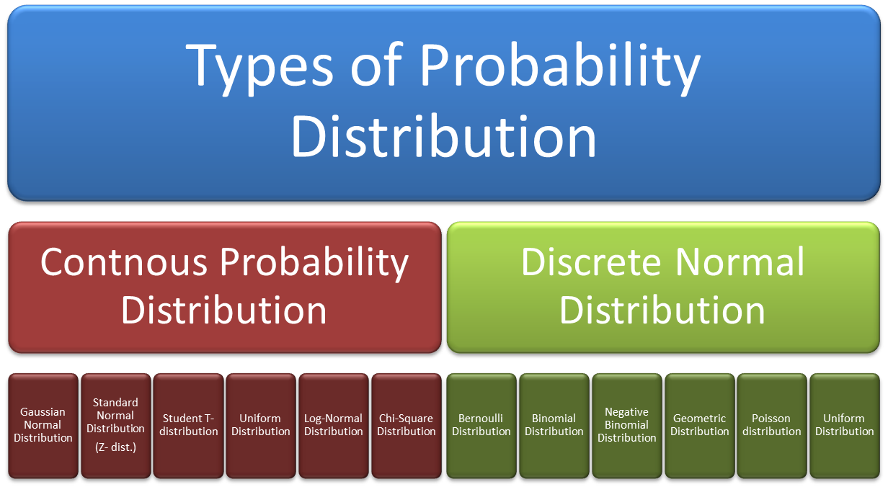

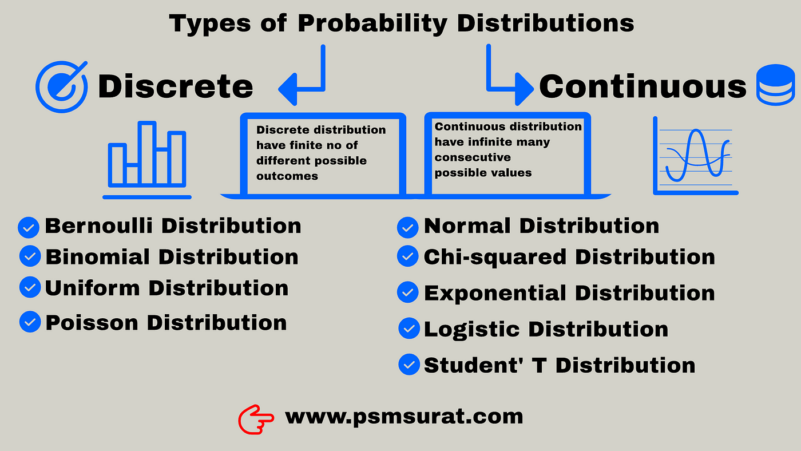

Some Important distributions